MIS 6360 Group Project - Part 2

This assignment is a group take home project. You should work with the members of your group to answer the questions provided. Collaboration with others outside of your group is not allowed and you are only allowed to work with the members of your group. The assignment is open book and open notes. You may use any resource at your disposal except for directly soliciting advice or input from someone not in your group. Please make sure all sources are cited. Do NOT give or share this assignment with others.

Please answer all of the questions listed below and submit your answers via eLearning. You should answer the questions directly in this document. Please note you should also submit the MS Project File you create and use to answer the questions. Answers will be graded for (1) accuracy and (2) level of adherence to effective business writing standards. Please make sure you answer all parts of each question. ***Please submit BOTH the Word document and your MS Project file.***

The following information is used to answer questions 1 and 2.

Project Description

The new software-controlled conveyor belt is an exciting project that moves and positions items on a conveyor belt with a high degree of accuracy (< 1 millimeter of error). The proposed project will produce a new system capable of automating the movement of a wide variety of warehouse materials commonly used in order fulfillment. The following information has been developed for you to use in completing the exercises.

Assumptions and Notes

A seven-day workweek is used for the whole year. No holidays.

The project should start on January 1 of the next year.

Splitting of activities is allowed.

Resources have identical capabilities and may be substituted for each other. For example, an activity requiring a design resource may be performed by any of the design resources working on the project.

Partial assignments are allowed.

***Activity durations are not fixed meaning adding resources to an activity decreases the duration of the activity.***

***Warning: Save your work frequently and make backup files as you answer each part.***

***You may be required to make additional assumptions to complete the assignment. If you do make an assumption, please clearly state the assumption and the reason for making it.***

Question 1 (50 points)

**This question is a continuation of the computer-controlled conveyor belt project begun in part 1. Use the included project file to answer the following questions.**

After showing your resource-constrained network to top management, they are very disappointed. After some explanation and negotiation, they make the following compromise with you:

* The project must be completed in no more than 300 days**.**
* **You may NOT make any changes to tasks 1, 2, 3, or 4.**
* One additional Design resource has already been added to the project.
* If you think it is beneficial, you may assign one additional development resources at the same cost rate as the original development resources.
* If this does not suffice, you may hire other people from the outside. Hire as few additional external people as possible because they cost $50 more per hour than your inside people.
* The scope of the project remains the same and the amount of work for each task may not be changed.
* Task dependencies may NOT be changed.
* Overtime is allowed, but the cost rate is 1.5 times the standard cost rate
* If overtime is used, overtime may not exceed 16 hours per day
* Splitting of tasks is allowed
* Resources assignments less than 100% are allowed
* ***Activity durations are not fixed meaning adding additional resources to an activity decreases the duration of the activity.***
* ***Your changes should minimize the impact to the overall project cost***

a. Include a screenshot of your final Gantt chart clearly identifying the critical path. What is the new finish time in number of days? What is the new finish date?

* The number of days for the project to finish is 297 days.
* The new finish date is Wednesday, 10/23/24.
* Gnatt chart with critical path:

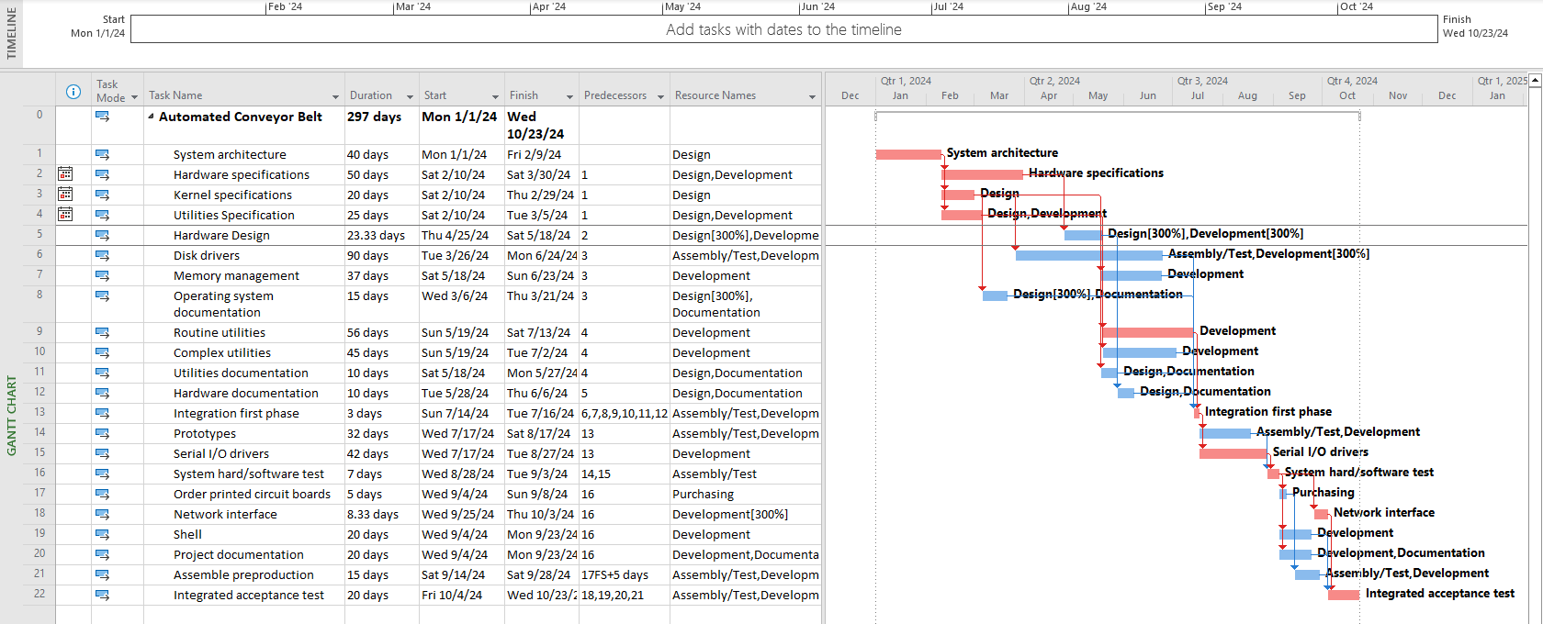

b. List all of the changes you made to the original project schedule.

* Make sure leveling options are the same as professor’s in his eLearning video
* In the Resource Sheet, add one additional Development resource at the same cost rate as the original development resources (increase from 200% to 300%)
* In the Resource Sheet, add overtime rates to all the resources (take the standard rate for each resource and multiply by 1.5)
  + Design- $337.50
  + Development- $195
  + Documentation- $112.50
  + Assembly- $97.50
  + Purchasing- $75
* (In the Gnatt Chat) Task 5: Increase both Development and Design units from 100% to 300%
* Task 6: Increase Development units to 300%
* Task 8: Increase Design units to 300%
* Task 18: Increase Development units to 300%
* Task 10: Add overtime to reduce task duration from 90 days to 45 days; added 360 hours of overtime to Development (45 days * 8hrs overtime/day)
* Task 13: Add overtime to reduce task duration from 35 days to 3 days; added 256 hours to both Assembly and Development (32 days * 8hrs of overtime/day)
* Task 15: Add overtime to reduce task duration from 85 days to 42 days; added 344 hours of overtime to Development (43 days * 8hrs of overtime/day)
* Task 16: Add overtime to reduce task duration from 15 days to 7 days; added 64 hours of overtime to Assembly (8 days * 8hr of overtime/day)
* Task 14: Add overtime to reduce task duration from 65 days to 32 days; added 264 hours of overtime to both Assembly and Development (33 days * 8hr of overtime/day)
* Used to be 263
* Task 7: Add overtime to reduce task duration from 75 days to 37 days; added 304 hours of overtime to Development (38 days * 8hrs of overtime/day)
* Task 9: Add overtime to reduce task duration from 60 days to 56 days; added 32 hours of overtime to Development (4 days * 8hrs of overtime/day)

c. What is the total cost of the project?

* $1,486,980.00

d. Include a graph of the total financial schedule over the life of the project by month. This is the planned value for the project. The graph should depict time on the x-axis and dollars on the y-axis over the life of the project.

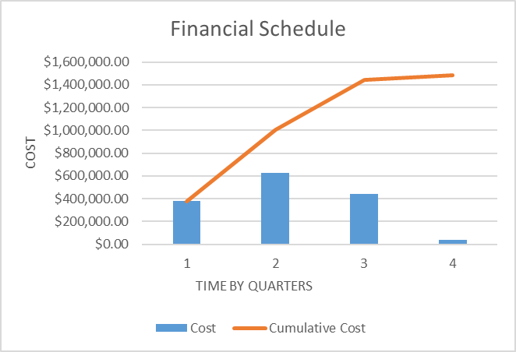

e. Include a screenshot of the total costs for each activity/work package.

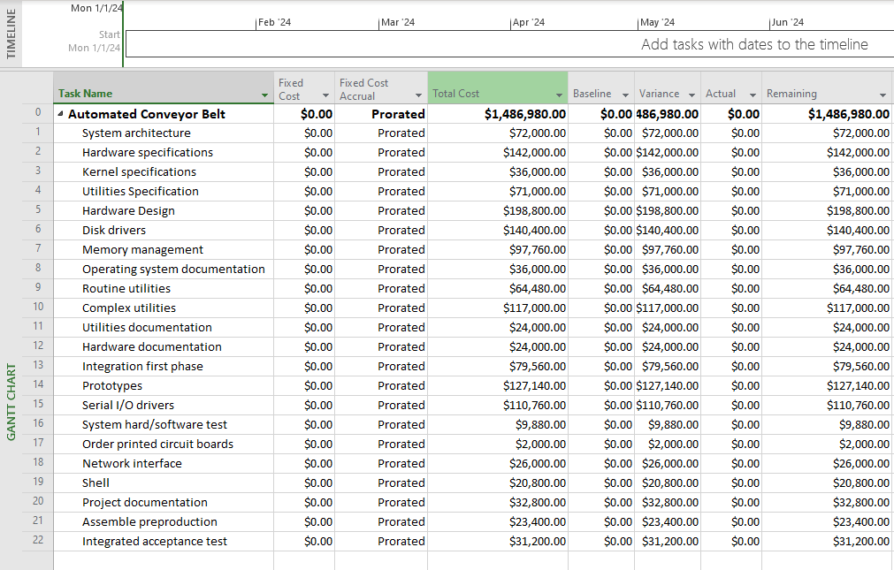

Remember, your financial schedule should follow your resource schedule, not the original network. Because the project has not started yet, all of your variances, schedule, cost, earned value, and actual cost should be zero. Once you are confident that you have the final schedule, save the file as a baseline. (Hint: Save a backup file just in case without baseline!)

Question 2 (50 points)

Prepare a status report using the information provided below. This requires saving your resource schedule as a baseline and inserting the appropriate status report date in MS Project. The MS Project tutorial on eLearning and the discussion forum pertaining to Earned Value Management may be of use in answering this question.

Activities Accomplished as of the end of the day February 28, 2024

|  |  |  |  |
| --- | --- | --- | --- |
| **Activity** | **Description** | **Actual Duration** | **Remaining Duration** |
| 1 | System Architecture | 40 | 0 |
| 2 | Hardware specifications | 19 | 40 |
| 3 | Kernel specifications | 19 | 10 |
| 4 | Utilities Specification | 19 | 20 |

a. Include a screenshot of the status report for the first quarter in table form that shows the PV, EV, AC, BAC, EAC, SV, CV, SPI, and CPI for (1) each work package and (2) the whole project.

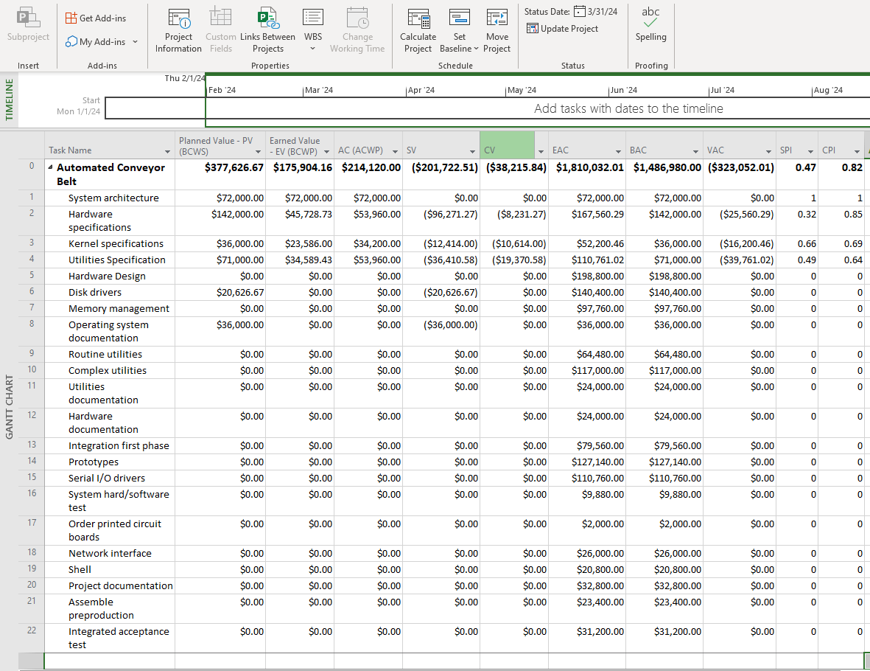

b. Based on the performance of the project team, what are the Estimated Cost at Completion (ECAC) and the Estimated Time at Completion (ETAC) for the project as a whole?

* ECAC = $1,810,032.01
* ETAC = 315.44 days

c. How is the project as a whole progressing in terms of cost and schedule? Be specific in your response and clearly identify the amount, if any, the project is over/under budget and the schedule change, if any, the project is ahead/behind schedule in number of days. (Schedule difference = estimated – original)

|  |  |  |  |
| --- | --- | --- | --- |
| **Project Name** | **Original Project Duration** | **Estimated Time at Completion (ETAC)** | **Schedule Difference** |
| SCCB | 297 days | 315.44 days | 18.44 days |

* We are behind schedule by 18.44 days.

|  |  |  |  |
| --- | --- | --- | --- |
| **Project Name** | **Original Project Cost** | **Estimated Cost at Completion (ECAC)** | **Cost Difference** |
| SCCB | $1,486,980.00 | $1,810,032.01 | $323,322.01 |

* We are over budget by $323,322.01

d. Complete the following table describing the performance of each task in the project so far. For each task, compare the original planned schedule and cost with the actual schedule and cost as of February 28. For tasks that are in progress, please also include the estimated scheduled finish data and the estimated cost at completion and compare these estimates with the original plan.

|  |  |  |  |  |
| --- | --- | --- | --- | --- |
| **Activity** | **Description** | **Original Planned Duration** | **Actual/Estimated Duration at Completion** | **Schedule Difference (Days)** |
| 1 | Architectural Decisions | 40 days | 40 days | 0 days |
| 2 | Hardware specifications | 50 days | 59 days | -9 days |
| 3 | Kernel specifications | 20 days | 29 days | -9 days |
| 4 | Utilities Specification | 25 days | 39 days | -14 days |

|  |  |  |  |  |
| --- | --- | --- | --- | --- |
| **Activity** | **Description** | **Original Planned Cost** | **Actual/Estimated Cost at Completion** | **Cost Difference (Dollars)** |
| 1 | Architectural Decisions | $72,000 | $72,000.00 | 0 |
| 2 | Hardware specifications | $142,000 | $167,560.29 | $25,560.29 |
| 3 | Kernel specifications | $36,000 | $52,200.46 | $16,200.46 |
| 4 | Utilities Specification | $71,000 | $110,761.02 | $39,761.02 |

e. Which activities performed as planned? Which activities did not go as planned?

* Activity 1 performed as planned.
* Activities 2, 3 and 4 did not go as planned.

f. What changes will you make moving forward to try and bring the project back on track?

* One change we will make is allocating better resources to complete the project on time without going over the budget. We noticed how our EV is not equal or higher than our PV, and that our actual/estimated cost and duration are much higher. Hence, an assumption we are making is that we are using numerous resources that are not being able to complete the project on time. So instead of having multiple people try to complete a task ineffectively, we want to bring in a high-performance team in which the number of people allocated to a resource decreases (reducing the cost) but the output of completed task increases (shortening the project duration).
* The first thing we will try to do is add overtime of up to 16hrs per day so as to avoid hiring new external people and minimize the impact on the cost of the project. For the task that already have 8hrs overtime added to them, we will add additional 8hrs per day to make sure the overtime doesn't exceed 16hrs per day. These additional resources should be able to solve the problem and decrease the duration back to below 300 days because there is only a schedule variance of 18.44 days. And if this does not solve the problem, we will hire one or two external people to complete the work. We understand that this will have some effect on the budget, but the priority is to complete this project in no more than 300 days.